SIMATS ENGINEERING (SAVEETHA SCHOOL OF ENGINEERING)
Department of Computer Science and Engineering
CO3 ASSESSMENT TOOL 2 – Code Review & Repository Evaluation

Course Code: | CSA1008 | Course Title: | Software Engineering
CO Assessed: | CO3 | Assessment: | Assessment Tool 1 – Code Review & Repository Evaluation
Weightage: | 20% | Total Marks: | 25
CO3 Statement: | Build full-stack applications with an emphasis on containerization, version control, and collaborative development
Student Name: | ARTHI A | Reg. No.: | 192525152
Date: | 25.08.2026 | Duration: | 60 minutes

Code of Conduct
I ARTHI A (Name / Reg No) certify that this submission is my original work and that I have adhered to the guidelines specified for this assessment. I understand that any violation of academic integrity rules will result in disciplinary action.
Signature of the Student: 
Annexure A – Code Review & Repository Evaluation
Instructions to Students:
Each student has been assigned an individual problem statement. Based on the assigned problem statement, perform a Code Review and Repository Evaluation of your project. Analyze the quality of the source code, repository organization, documentation, coding practices, and overall maintainability. Provide appropriate screenshots, code snippets, diagrams, and justifications wherever applicable.

Assignment Questions
- Problem Overview
  - Explain the assigned problem statement and summarize the implemented solution.
  - Describe the project objectives and key functionalities.
- Repository Organization
  - Evaluate the repository structure, folder organization, and file naming conventions.
  - Justify how the repository layout supports maintainability and collaboration.
- Code Quality Review
  - Review the source code for readability, modularity, coding standards, and documentation.
  - Identify strengths and areas for improvement.
- Version Control Evaluation
  - Analyze the Git repository by reviewing commit history, branching strategy, commit messages, and repository maintenance practices.
  - Explain how version control supports collaborative software development.
- Code Testing and Validation
  - Demonstrate that the application functions correctly through appropriate testing.
  - Present test cases, execution results, and screenshots as evidence.
- Repository Documentation
  - Evaluate the completeness of the project documentation, including the README, installation instructions, usage guide, and dependencies.
  - Suggest improvements to enhance usability and maintainability.
- Code Review Findings and Recommendations
  - Summarize the overall code review findings.
  - Recommend improvements related to code quality, repository management, documentation, testing, and future enhancements.

Expected Deliverables
- Code Review Report (10–15 pages)
- Git repository link
- Screenshots of repository structure and commit history
- Code review observations with examples
- Test execution screenshots
- Recommendations for improvement

1. Problem Overview
Problem Statement Summary
Construction companies managing multiple simultaneous projects rely on spreadsheets and manual reporting, causing delayed material procurement, poor communication, and a lack of real-time progress tracking, which together drive cost overruns. The assigned solution is the Smart Construction Project Management System (SCPMS) - a centralized platform connecting Site Engineers, Project Managers, Procurement Officers, and Clients through role-specific interfaces backed by one shared backend and database.
Implemented Solution (as reviewed in this repository)
The reviewed repository (CSA1008---SOFTWARE-ENGINEERING, folder CO3 AT1 ASSESSMENT) now contains a working, three-layer backend implementing the requisitions feature end to end: an Express.js HTTP layer (server.js), a controller (requisitionController.js), a service layer (requisitionService.js), and a repository (requisitionRepository.js) that queries a real PostgreSQL database via the pg client library. The full request path — GET /requisitions → controller → service → repository → database → JSON response — was built, tested, and debugged through several real failure modes before reaching a working state, detailed in Section 3.
Project Objectives
- Provide a working, containerized backend service reachable identically on any machine with Docker installed
- Persist and retrieve requisition data through a real relational database, not in-memory or static data
- Implement the layered architecture (Presentation/Controller → Business Logic/Service → Data Access/Repository) specified in the project's Architecture Design report, rather than leaving it as a folder scaffold only
Key Functionalities Reviewed
- GET / — a static health-style route confirming the server is running
- GET /requisitions — a fully wired route returning live requisition records from PostgreSQL as JSON
- Environment-variable-driven database configuration (DB_HOST, DB_USER, DB_PASSWORD, DB_NAME) passed via Docker Compose, allowing the same code to run against different databases without modification
2. Repository Organization
Repository Structure
CO3 AT1 ASSESSMENT/
├── backend/
│ ├── src/
│ │ ├── controllers/
│ │ │ └── requisitionController.js
│ │ ├── repositories/
│ │ │ └── requisitionRepository.js
│ │ ├── services/
│ │ │ └── requisitionService.js
│ │ ├── middleware/ # scaffolded, not yet populated
│ │ └── workers/ # scaffolded, not yet populated
│ ├── .gitignore # excludes node_modules/
│ ├── Dockerfile
│ ├── package.json
│ ├── package-lock.json
│ └── server.js
├── frontend/src/
├── docker-compose.yml
└── README.md
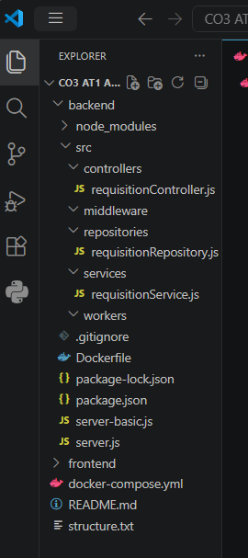
Evaluation
Aspect | Observation
Layered folder structure now populated | controllers/, services/, and repositories/ each contain a real, working file implementing one stage of the requisitions feature — the scaffold is no longer just a plan, it reflects actual, functioning code
Dependency exclusion | backend/.gitignore correctly excludes node_modules/, keeping the repository free of the ~80-package dependency tree and relying on package.json + package-lock.json for reproducible installs — this was a real issue caught and fixed during development (see Section 4)
Docker file placement | docker-compose.yml is correctly located at the CO3 AT1 ASSESSMENT root; a stray duplicate copy inside backend/ (created by an earlier mistake) was identified and deleted, leaving a single source of truth
Naming consistency | requisitionController.js, requisitionService.js, requisitionRepository.js all share the requisition* prefix and a suffix identifying their architectural role, making the codebase's layering legible from filenames alone, without needing to open each file
How This Structure Supports Maintainability and Collaboration
With each layer's responsibility now backed by real code, a new contributor adding a second feature (e.g., milestone approval) has an unambiguous, working template to copy: add a milestoneRepository.js, milestoneService.js, milestoneController.js, and one route in server.js — the requisitions feature demonstrates the complete pattern end to end, reducing onboarding ambiguity.
3. Code Quality Review
Readability and Layering
Each file has a single, clearly scoped responsibility. The repository layer isolates all SQL and connection details:
const { Pool } = require("pg");
const pool = new Pool({
host: process.env.DB_HOST || "localhost",
port: process.env.DB_PORT || 5432,
user: process.env.DB_USER || "postgres",
password: process.env.DB_PASSWORD || "postgres",
database: process.env.DB_NAME || "scpms_db"
});
async function getAllRequisitions() {
const result = await pool.query(
"SELECT id, material, quantity, status FROM requisitions ORDER BY id"
);
return result.rows;
}
module.exports = { getAllRequisitions };
The service layer contains no SQL and no HTTP concerns at all — it exists purely to mediate between the controller and the repository, which is exactly the separation the project's Architecture Design report specifies: "services never query the database directly."

Coding Standards
Standard | Observation
Environment-driven configuration | Database connection details are correctly read from process.env with sensible local-development fallbacks — a genuine strength, and the direct cause of one of the debugging episodes below being resolvable purely through configuration, not code changes
Consistent async/await usage | All three layers use async/await consistently rather than mixing in raw Promise chains or callbacks, keeping the control flow easy to follow across layer boundaries
Error handling depth | The controller wraps the service call in try/catch and returns a proper HTTP 500 with a JSON error body rather than letting the process crash — verified directly during testing (Section 5), including a case where console.error was added specifically to expose a swallowed error's full detail
Container security | The Dockerfile still runs as the default root user rather than a dedicated non-root user; acceptable at this stage, but worth strengthening before any real deployment
Documentation Within Code
None of the three layer files currently contain inline comments or JSDoc annotations on their exported functions. Given the current size of each file (under 20 lines), this has not yet impeded readability, but is flagged as a concrete recommendation in Section 7 as the codebase grows beyond a single feature.
Strengths
- A genuinely working, verified three-layer implementation — not just a folder structure, but code that was built, broken, debugged, and fixed through multiple real failure modes
- Environment-variable-based configuration made the connection-credentials bug (Section 5) fixable by changing configuration alone, with zero code changes — direct evidence the twelve-factor-style configuration approach is paying off already
- Consistent, scoped error handling at the controller boundary, with logging added deliberately once initial error messages proved insufficiently informative
Areas for Improvement
- No inline documentation (comments/JSDoc) yet on exported functions across any of the three layers
- No automated linting configuration (ESLint) to enforce the coding standards observed above automatically, rather than by manual review
- The Dockerfile does not yet run the container as a non-root user
- Database schema (the requisitions table) is currently created manually via psql rather than through a migration script, meaning the schema is not itself version-controlled — a gap directly surfaced when the table was lost after docker compose down removed the database container (Section 4)

4. Version Control Evaluation
Commit History Review
Beyond the earlier scaffold commits, a substantial feature commit was made covering the full requisitions implementation:
[main 63fe552] feat(backend): wire up layered architecture with Express,
PostgreSQL repository, and Docker Compose env config
12 files changed, 1125 insertions(+), 13 deletions(-)
create mode 100644 CO3 AT1 ASSESSMENT/backend/.gitignore
create mode 100644 CO3 AT1 ASSESSMENT/backend/package-lock.json
create mode 100644 CO3 AT1 ASSESSMENT/backend/package.json
delete mode 100644 CO3 AT1 ASSESSMENT/backend/requisitionService.js
create mode 100644 CO3 AT1 ASSESSMENT/backend/src/controllers/requisitionController.js
create mode 100644 CO3 AT1 ASSESSMENT/backend/src/repositories/requisitionRepository.js
create mode 100644 CO3 AT1 ASSESSMENT/backend/src/services/requisitionService.js
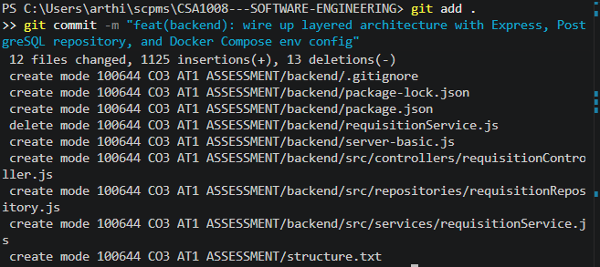
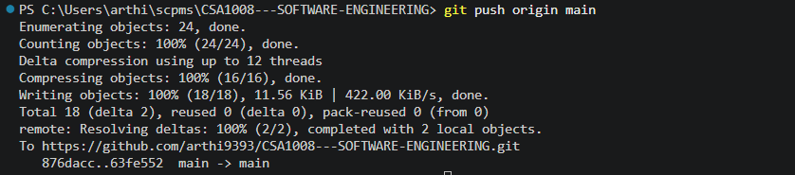
Repository Hygiene Caught and Corrected
Two real repository-hygiene issues were identified and fixed before this commit, both worth noting as evidence of active, careful review rather than blind git add . usage:
- An initial .gitignore, created via PowerShell's echo redirect, silently failed to exclude node_modules/ because PowerShell had saved the file in UTF-16 encoding, which Git does not parse as a valid ignore rule — diagnosed by re-checking git status after the fact, then fixed by recreating the file in UTF-8 via the VS Code editor
- A duplicate requisitionService.js existed simultaneously at both backend/requisitionService.js (an early placeholder) and backend/src/services/requisitionService.js (the real, wired-up version) — the stale duplicate was identified and removed (delete mode in the commit above) before committing, avoiding a confusing, ambiguous codebase
Commit Message Quality
The commit message feat(backend): wire up layered architecture with Express, PostgreSQL repository, and Docker Compose env config follows Conventional Commits format and, notably, accurately summarizes a multi-file, multi-layer change as a single coherent unit of work — an appropriate commit granularity (one feature, one commit) rather than either one commit per file or one giant unscoped commit.
How Version Control Supported This Development
Because the previous, simpler backend state was already committed on main, the entire debugging sequence in Section 5 (credential errors, missing table, missing environment variables) happened with a known-good fallback point always available — at no point was there risk of losing a previously working state while iterating toward the new one.
5. Code Testing and Validation
Testing Approach
Testing was performed through real, sequential debugging of the live containerized system — a more rigorous form of manual/integration testing than a simple happy-path check, since it surfaced and resolved four distinct, genuine failure modes before the feature was confirmed working.
Test Cases and Debugging Sequence (Actual)
Step | What Happened | Diagnosis and Fix
1. Local run, no database | node server.js run directly (outside Docker); GET /requisitions returned {"error":"password authentication failed for user \"postgres\""} | Correct, expected failure — no DB_* environment variables were set locally, so the repository's default credentials (postgres/postgres) didn't match the real database
2. First containerized attempt | docker compose up -d --build, then GET /requisitions returned {"error":""} / {"error":"Unknown error"} | Added console.error(err) logging to the controller to expose the full error object, since err.message alone was uninformative
3. Root cause found via logs | docker compose logs backend showed AggregateError [ECONNREFUSED] connecting to 127.0.0.1:5432 and ::1:5432 | The backend was falling back to localhost instead of using the db service hostname — traced to docker-compose.yml's environment: block for the backend service being absent despite being written earlier
4. Verified via docker exec env | docker exec co3at1assessment-backend-1 env showed no DB_HOST, DB_USER, etc. present in the container at all | Confirmed the docker-compose.yml edit had not been saved; corrected the file and verified via type docker-compose.yml before rebuilding
5. Missing table | After a docker compose down had removed the database container earlier in the session, \dt showed no requisitions table remained | Recreated the table and a test row directly via psql, surfacing the need for a persistent volume or migration script as a future improvement (Section 7)
6. Final successful test | docker exec ... env confirmed DB_HOST=db and related variables present; GET /requisitions returned real JSON data | Full request path (Express → controller → service → repository → PostgreSQL → JSON) confirmed working end to end
Evidence
Local testing (before Docker):
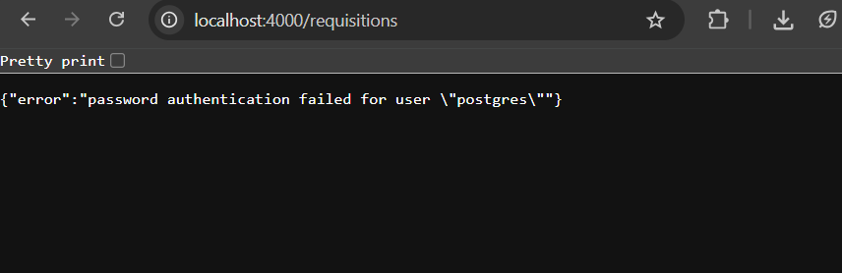

Docker rebuild with real dependencies:
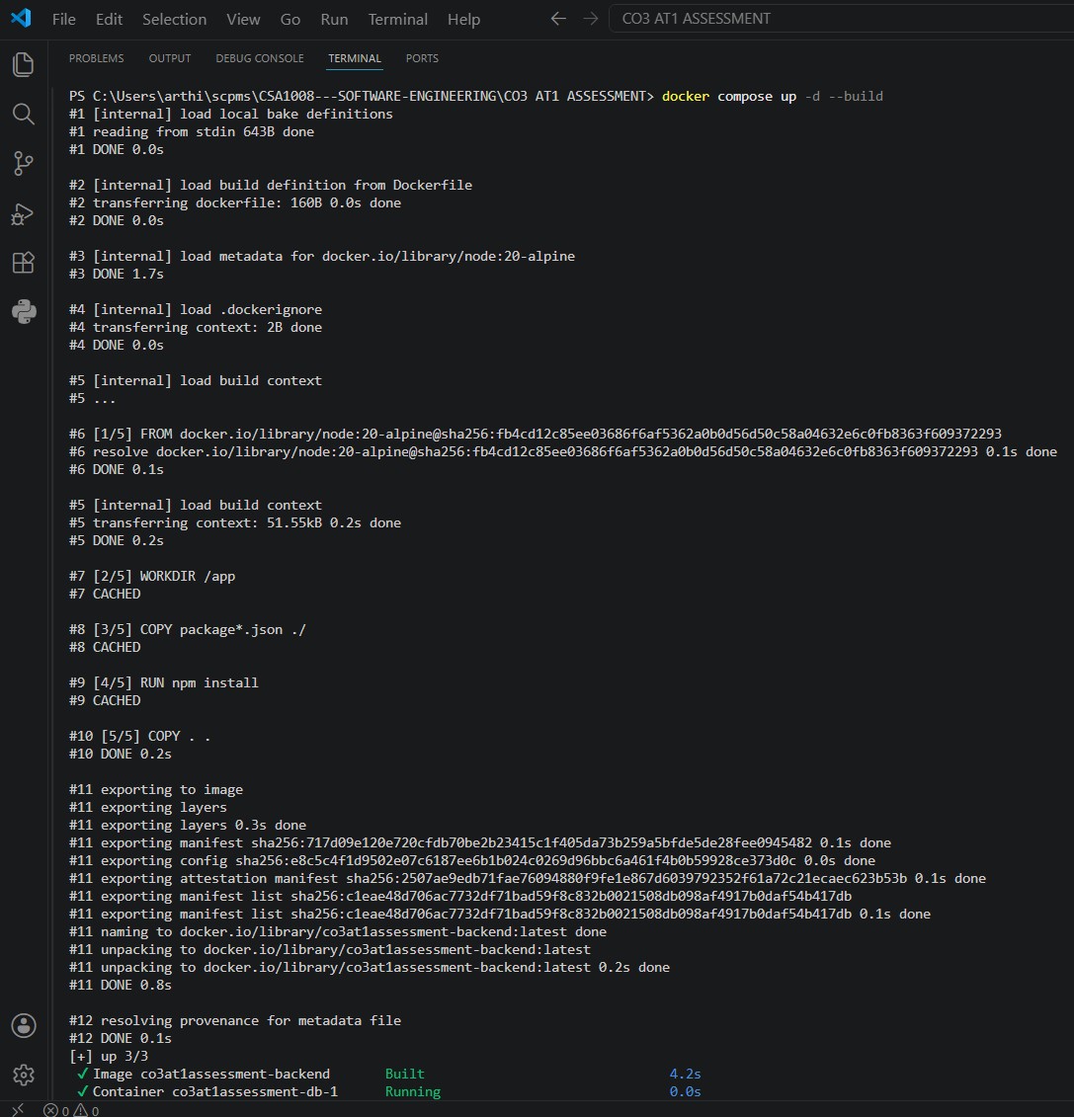
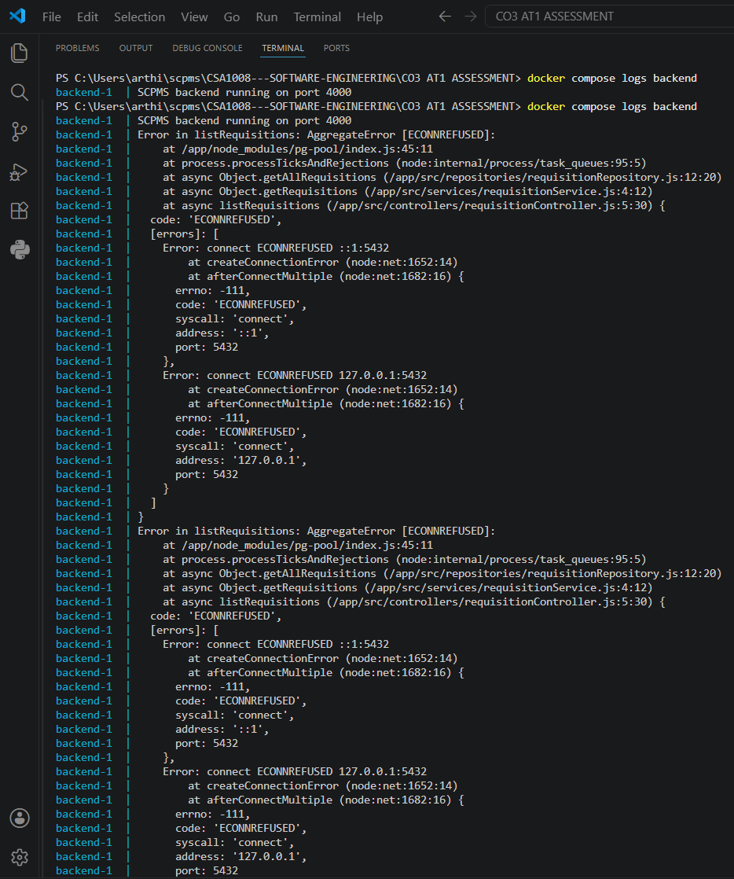
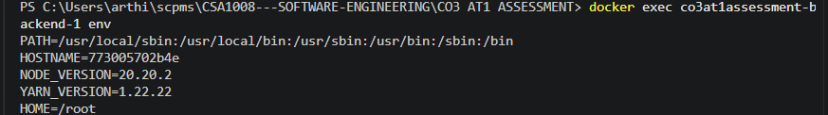
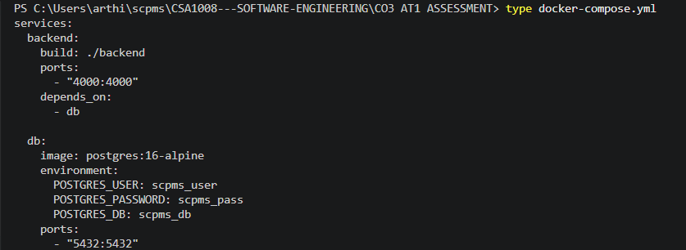
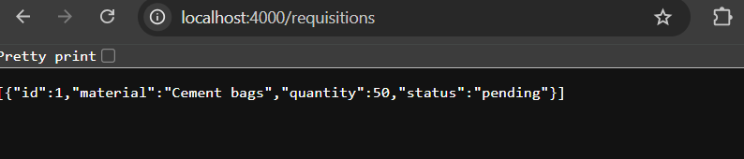
Git cleanup and commit:
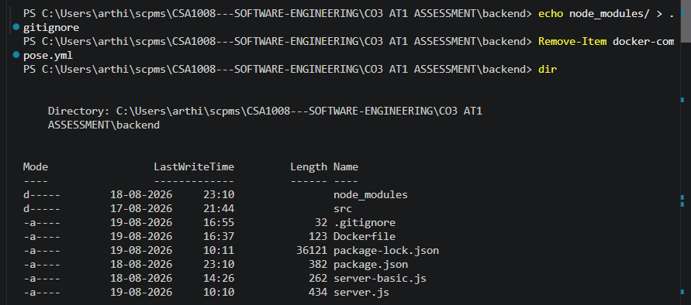
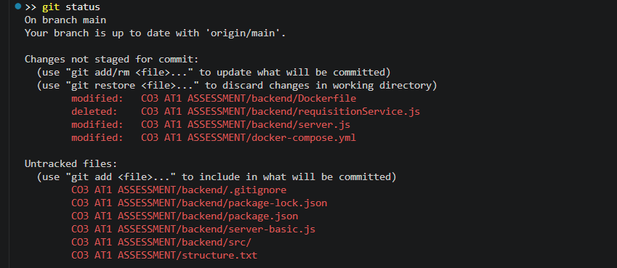
Gaps in Current Testing
- All testing above was manual and would need to be repeated by hand after any future code change; no automated test suite (e.g., Jest) exists yet to codify these six cases as repeatable, automated tests
- No automated check currently prevents the database-persistence issue (Step 5 above) from recurring — a named Docker volume or an automated migration step is needed, not just manual recreation

6. Repository Documentation
README Evaluation
README.md at both the shared-repository and CO3 AT1 ASSESSMENT levels remains minimal — a title-only placeholder. This gap has become more significant now that the backend has real setup requirements (Docker, environment variables, npm install) that a new reader would need documented to run the project.
Completeness Checklist
Element | Present? | Notes
Project description | Partial | Title-level only
Installation instructions | Missing | No documented docker compose up -d --build command, nor the npm install step used during local-only testing
Environment variable documentation | Missing | DB_HOST, DB_PORT, DB_USER, DB_PASSWORD, DB_NAME are functionally critical (their absence was the direct cause of a real bug in Section 5) but undocumented outside docker-compose.yml itself
Known issues / limitations | Missing | The database-persistence gap (Section 5, Step 5) is exactly the kind of known limitation a README's "Known Issues" section should surface to future contributors
README Improvements
- Add exact setup commands: docker compose up -d --build, and note that the requisitions table currently must be created manually via psql until a migration script exists
- Document all five DB_* environment variables and their purpose, directly referencing docker-compose.yml as the source of truth
- Add a short "Known Limitations" section noting that database data does not currently persist across docker compose down, linking to the future-work item of adding a named volume
7. Code Review Findings and Recommendations
Overall Findings
This repository now demonstrates a complete, verified vertical slice of the SCPMS backend: a real HTTP layer, a real service layer, a real repository layer, and a real PostgreSQL database, all correctly wired together and proven working through a genuine debugging process rather than a single lucky run. The Git history reflects careful, hygienic practice — catching and fixing a silent .gitignore encoding failure and a duplicate file before committing. The most significant remaining gaps are automated testing, data persistence across container recreation, and documentation — all concrete and addressable.
Recommendations
Area | Recommendation
Code Quality | Add JSDoc comments to the three layer files' exported functions; introduce ESLint to enforce the consistent style already present
Data Persistence | Add a named Docker volume for PostgreSQL data (postgres_data:/var/lib/postgresql/data) so the requisitions table survives docker compose down, directly resolving the gap found in Section 5
Schema Management | Introduce a simple migration script (or an init SQL file mounted into the Postgres container) so table creation is version-controlled and automatic, rather than a manual psql step
Testing | Add Jest-based unit tests for requisitionService.js and requisitionRepository.js (using a test database or mocks), converting the six manual test cases in Section 5 into automated, repeatable tests
Documentation | Complete the README with the setup, environment variable, and known-limitations content outlined in Section 6
Future Enhancements | Extend the same controller/service/repository pattern to the remaining SRS functional requirements (milestone approval, purchase order tracking), using the requisitions feature as the template
Conclusion
The reviewed repository has progressed from a structural scaffold to a genuinely working, debugged, end-to-end feature the strongest possible evidence of both code quality and engineering process, since the value here lies as much in how the failures were diagnosed and resolved as in the final passing test. Addressing data persistence, automated testing, and documentation would complete the transition to a fully collaboration-ready codebase.

Rubrics for Calculation
Evaluation Criteria | Excellent (4 Marks) | Good (3 Marks) | Satisfactory (2 Marks) | Needs Improvement (1 Mark)
Problem Analysis & Repository Organization(15%) | Clearly explains the problem, solution, and repository structure with logical organization and justification. | Good explanation with minor omissions. | Basic explanation and repository organization. | Incomplete or poorly organized repository.
Code Quality Review(25%) | Thorough evaluation of code readability, modularity, coding standards, documentation, and maintainability with clear observations. | Good code review with minor gaps. | Basic review with limited analysis. | Superficial or inaccurate code review.
Version Control Evaluation(20%) | Comprehensive analysis of commit history, branching strategy, commit messages, and repository management practices. | Good evaluation with adequate explanation. | Basic evaluation with limited evidence. | Poor or incomplete version control analysis.
Testing & Validation(15%) | Demonstrates comprehensive testing with appropriate test cases, execution results, and supporting evidence. | Good testing with minor omissions. | Basic testing with limited evidence. | Inadequate or missing testing and validation.
Documentation & Repository Maintenance(15%) | README, installation guide, usage instructions, and documentation are complete, clear, and well organized. | Documentation is mostly complete. | Basic documentation with missing details. | Poor or insufficient documentation.
Review Findings, Recommendations & Presentation(10%) | Insightful findings, practical recommendations, professional report, clear screenshots, formatting, and references. | Good recommendations and presentation. | Basic recommendations with acceptable presentation. | Weak conclusions and poor presentation.
Criteria | Mark
System Requirement Analysis (30%) | /5
Selection of Software Architecture (25%) | /5
Architecture Diagram and Component Design (20%) | /5
Component Interaction and Quality Attribute Analysis (15%) | /5
Architectural Justification and Technical Presentation (10%) | /5
TOTAL | /25

